Comparative Statistics of the State of Education and Number of Crimes
Extract from the Revue Encyclopédique, August, 1832
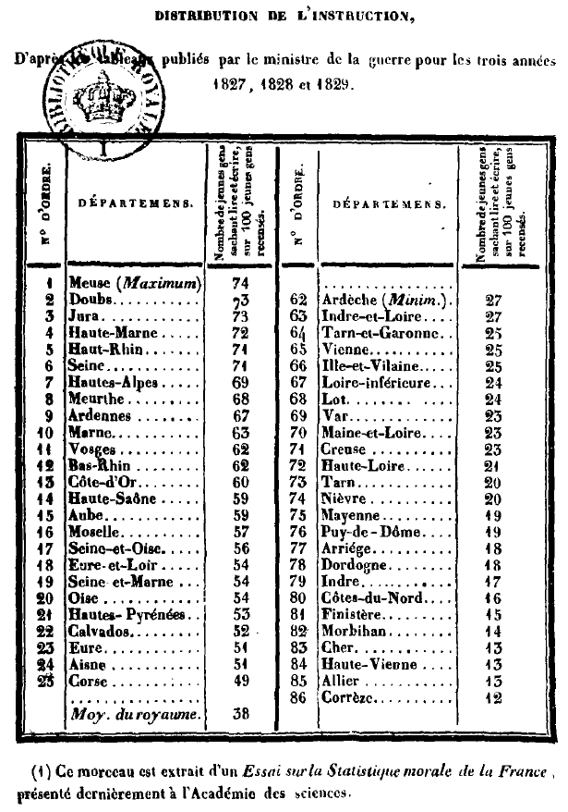
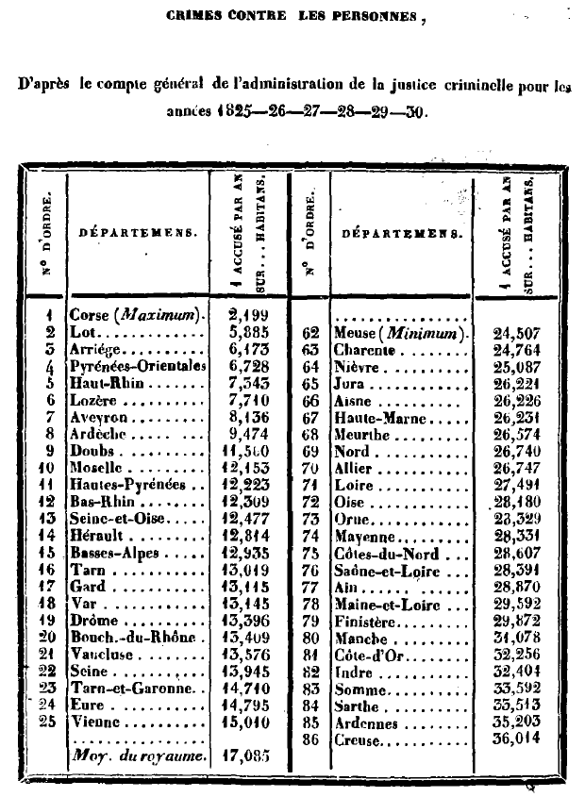
Ignorance is, it is said, the main cause of crime, and to make men better and happier, it suffices to give them instruction. This opinion was maintained before the chambers and in the royal society of the prisons. It is generally adopted in France.
Since the publication of the account of criminal justice, it has been reproduced with so much assurance, and in such varied forms, that it has today become a vulgar truth, a commonplace which no longer requires proof.
What was the exact basis to establish this opinion? The observation, that the departments where instruction is most widespread are those where the least crimes are committed. Is it so? That's the whole question. To solve it, it is necessary to determine exactly, during a certain number of years, the distribution of the instruction and that of the crimes in the various parts of the kingdom; we believe we have arrived at this.
The difference which exists, with respect to education, between what has since been called obscure France and enlightened France, was noticed for the first time in 1823 by M. Malte-Brun as a fact worthy of the most serious attention. The number of male students admitted to the schools was the only element then known and of which this author made use; it is also the only one considered in the researches which were later published on the same subject.
It was extremely probable that, in general, in each department, the number of scholars must roughly represent the state of education of the mass of the inhabitants. We could fear, however, that the returns addressed to the ministry had not been made everywhere with the same precision, and it was not known, moreover, how many children were educated in their families or by unofficial teachers.
We now have a safer way to establish instruction distribution. Since the lifting of the class of 1827, the Ministry of War has subjected young people called up to join the army to an examination which, at the time of recruitment, recognizes the number of those who know how to read and write. It is from the information collected on this subject for three years that we have drawn up, for the various departments, the comparative map of instruction. It deserves more credit than what it represents since, for the same period, it encompasses men of all classes of society without distinction, and that the ratios are not calculated with the total population, often badly known, but with the number of young people registered on the census rolls.
What strikes first, when you look at the map of instruction, is the light tint almost uniformly spread over the thirty departments of the north-east, which lie above a straight line which one would draw from the department of Manche to that of the Ain. The departments of Meuse, Doubs, Jura, Haute-Marne and Haut-Rhin, included in this series, present the most favorable proportions. Among a hundred young people registered on the census rolls, there are seventy-one to seventy-four, or nearly three-quarters, who can read and write.
It is not in the southern provinces that there is, as is claimed, the most ignorance, but in those of the west and the center, in Berry, Limousin and Brittany. Out of a hundred young people, the department of Finistère shows only fifteen who know how to read and write; that of Morbihan, fourteen; those of Cher, Haute-Vienne and Allier, thirteen; and finally that of Correze, only twelve, or about an eighth. We must accept that the west the departments of Deux-Sevres, Charente-Inférieure, Charente, Gironde, and Basses-Pyrénées, are above the average for the kingdom. In the department of Corsica, which is believed to be far behind in terms of education, half of the young people (0.49) can read and write. There are sixty departments which have not reached this proportion.
Let us now compare this map to that of crimes against persons: The maximum of these crimes falls in the department of Corsica, in the south-eastern provinces and in Alsace. Is this where there is more ignorance? Our map provides evidence to the contrary. On the other hand, the minimum is found in the western and central provinces. Is it there where the most education reigns? Obviously, the coincidence we talked about does not exist...
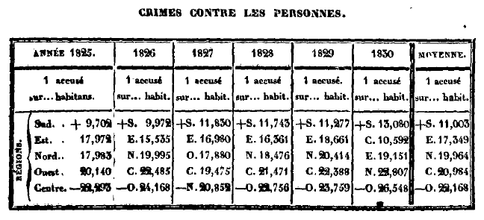
The departments of the southern region are, during the six years, those where the most crimes against persons are found. These crimes are twice as numerous there as in the departments of the western and central regions, which offer about as many as each other. The differences for the departments taken in isolation are even greater.
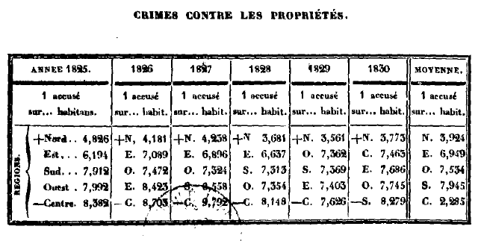
The maximum in property crimes is consistently found in the northern region, which, for crimes against persons, came only in third order; and with one exception for the year 1830, the results of which may have been altered by the causes we have indicated, the minimum always falls in the central region, where attacks on property are generally once more rare than in the northern one.
The geographical distribution of crimes against persons and against property, whatever the cause, is today perfectly known. It reproduces itself each year uniformly. This point having been well established, one could no longer, it seems to us, dispute the value of our results except by claiming that, even according to our work, the distribution of instruction still remains uncertain and accidental, that it can change from one year to another, and according to the elements which one will employ; that consequently, relative to this coincidence, nothing can yet be affirmed. We will observe that if the order in which the departments are arranged in the preceding table is not strictly exact, it is nonetheless certain that, as soon as the departments are united in groups, the partial errors compensate for each other, that this order becomes almost invariable, and that it is even then determined by numerical proportions not very different from each other. To be convinced of this, it is sufficient to take a look at the following table drawn up from very diverse elements collected over several years:
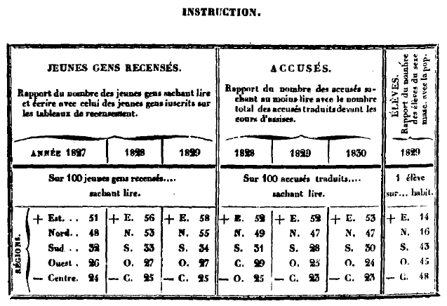
The five regions classified according to the education of their inhabitants follow each other each year in the same vertical order: east, north, south, west, center . The west, it is true, appears, once in seven, immediately after the center, instead of coming before; but it should be observed that the figure of these two regions being roughly the same, can alternate without the order being really inverted.
In the three tables, always the region of the east presents at least twice as much education as that of the center. It even offers three times as many in the table of the ratio of pupils to population.
The general results of the map of instruction are therefore fully confirmed, and it is shown that the departments where there is the most ignorance are not, as it is always affirmed, those where more crimes against people are committed. It would be useless to speak here of attacks on property, since they take place principally in the departments where there is the most instruction. It has long been recognized that they should no longer be attributed to ignorance, as was done previously.
The changes that time can bring about in this distribution of instruction are not very perceptible, because the number of pupils increasing everywhere at the same time, the different parts of the kingdom always preserve between them nearly the same order. Here is the proof:
According to the tables annexed to the bill on primary education presented last year to the chamber of peers, we see that in 1817, fifteen years ago, the maximum of instruction was as it is today. in the northeast, in the district of the university academies of Metz, Strasbourg, Besançon, Douai and Dijon, where the students were with the population in the ratio of 1 in 14, 14, 15, 16 and 17. The minimum also fell in the west and the center, in the district of the academies of Lyon, Bourges, Clermont, Grenoble, Rennes, where there was only one pupil out of 113, 126, 190, 158 and 567 residents.
This proportion in 1827, ten years later, had increased without the order having materially changed. The maximum was still found in the academies of Besançon, Metz, Amiens, Strasbourg and Dijon, where the ratio of pupils to residents was one in 11, 11, 12, 12 and 15; the minimum in those of Angers, Limoges, Orleans, Rennes and Clermont, where this ratio was only one out of 74, 92, 128, 150 and 159 residents. These academies therefore always follow each other more or less in the same order, but with more favorable proportions.
In attributing to lack of instruction most of the crimes against persons committed in the south, it was necessary, to be consistent, to admit at the same time that the individuals who are guilty of them are more ignorant than those who only harm property. This is also what we did not doubt. Now that the account of justice has reported, for three years, the state of instruction of the accused, do we notice that there is indeed less ignorance among the individuals prosecuted for crimes against persons than among the others? Far from it, it is precisely the opposite.
Amongst the attacks on property, thirty-eight defendants out of a hundred have received some instruction; there are forty-two in attacks against people. There is, moreover, a fact which we cannot conceal: it is that, among these last crimes, those which suppose the most depravity, of perversity, seem in general to be committed preferably by educated defendants. Thus the blows and wounds against foreigners give the proportion of forty-three educated defendants out of a hundred: the blows and wounds against ascendants 0.44; indecent assault on adults 0.45; on children , 0.47; murder, 47, assassination 49; finally poisoning also 49, or twice as much as theft on a public road.
We will examine a final argument which is found in most writings on popular education, and which is believed to be unanswerable. The proof that ignorance is the principal cause of crime is, it is said, that at various times in England or at home it has been recognized that half or two-thirds of the prisoners could not read. What could we conclude from this? Absolutely nothing, except that it was so. For this fact to have become of any importance, it would have been necessary to prove that the mass of the population from which these prisoners came was better educated, and this is what was ignored. When three-fourths of the prisoners could neither read nor write, if in the mass of the population four-fifths of the inhabitants of the same sex and of the same age were entirely illiterate, these prisoners would then find themselves proportionally the most educated, and ignorance could no longer be regarded as the cause of their crimes.
We will perhaps be reproached for overturning theories long since consecrated by the most respectable authorities: We answer that here we are not making any doctrine; we expose what is, without pretending to explain it. We are convinced, moreover, that any error in the end can only be fatal, and that to be useful to science and to men it is necessary to know how to place the authority of facts before that of names, and never to sacrifice truth to secondary considerations.
If our researches were not to be limited to France, we could add that these results, so little foreseen, agree with those obtained for the most enlightened countries by men full of knowledge and of good faith. In England, in Germany, in the United States, where until a few years ago they celebrated the happy influence of enlightenment and industry on moral improvement, it is already recognized that it is not enough not to found schools to prevent the progress of demoralization, and that it is necessary to look for another remedy for the evil which works up society.

One will perhaps be tempted to conclude from the foregoing that the cultivation of intelligence, far from weakening criminal inclinations, tends rather to strengthen them. This would undoubtedly be a new error.
Education is an instrument which can be used well or badly. That which we are going to draw from our elementary schools, and which consists only in knowing, in a rather imperfect way, how to read, write and calculate, cannot compensate for the lack of education and does not seem to have a great influence on the morality. We don't think it makes you more depraved or better. We would find it difficult to understand how it would suffice to train a man in certain almost material operations to immediately give him regular morals, and develop in him feelings of honor and probity.
Moreover, we are far from claiming that this knowledge is useless, and we sincerely applaud the zeal of the honorable men who, for fifteen years, have endeavored to spread this among us. If it does not offer as many advantages as one supposed at first, it at least destroys absurd or harmful prejudices, giving some habits of order, allowing to engage in less painful work, and can thus contribute to making the condition of the working classes more pleasant.
Guerry

By reporting, in the Journal des Débats of July 21, 1813, on the Statistics of the Kingdom of Portugal and the Algarve, by Mr. Adrien Balbi. It is to be noticed that in this work of the Venetian geographer we find the first documents which were published on the state of public instruction in France.
Since this work was presented to the Academy of Sciences, we believe we have found better proof of the influence of education on the reduction in the number of crimes. <<if we can demonstrate that young criminals become rarer as education spreads more. Now, the number of the accused, aged less than 16 years, which was 143 in 1828, was no longer so, in 1830, but it was 114; instead of 1,278 defendants, aged 16 to 24, which were counted in 1828, there were only 1,161 in 1830. This progression has always been decreasing since we began to note it. » Without first examining the principle which we have just laid down, it would not be contestable. We shall confine ourselves, for all answer, to giving the number of the young accused during the five years comprised from 1826 to 1830 inclusive. We will only observe that the number of crimes prosecuted having somewhat diminished in 1830, by the causes which we have indicated, it is not surprising that the number of accused people of all ages was also found to be lower than during the previous year. Crimes Against Persons and Against Property Year: 1826 1827 1828 1829 1830 Under 16 … 124 136 143 117 114 From 16 to 21 years old ………… 1101 1022 1278 1126 1161 Now it is easy to judge whether the number of young criminals offers, as it has been said, an ever-decreasing progression.
The Seventh Report of the committee of the society for the prison discipline, appendix, pag. 108. Report of the select committee of the House of Commons, appointed to inquire into the cause of the increase in the number of criminals, commitments and convictions in England and Wales (Juin 22, 1827). London medical Repository, new series, tom.III , pag. 337. Brougham.- Speech in the House of commons, 28th. juin 1820. John Miller. - lnquiry into the present state of the statute of criminal law of England. (London, 1822, pag. 231). Ran-Gœttingishe ; elehrte Anzeigen ( 1828, t. 1er, pag. 58 ). Julius. -Vorlesungen über die Gefangnisskunde, etc. (Berlin, 1831, 8°. Zellweger.-Neue Verhandlungen der Schweizrischen gemeinnützigen Gesellschaft über Erzeihungsween, Gewerbfleiss, und Armenpflege. Zürich, 1827, tom. III, pag. 257. First annual Report of the board of managers of the prison discipline society. (Boston, etc, pag. 83). Statistical illustrations of the British empire compiled by the order of the London Statistical Society, page IX. London, 1827; 1 vol. in-8°. Quetelet.- Recherches sur le penchant au crime, pages 44 et 78. Mémoires de l'Académie de Bruxelles, T . VII. 1831.) A . de Candolle.- De la statistique criminelle. (Bibliothèque univ. de Gnève, janvier 1831.) Two magistrates of the royal court of Paris, MM. G. De Beaumont and a. De Tocqueville, who have just traveled through the United States of North America, where, for two years, they collected a considerable number of documents of the greatest interest on the applications of the penitentiary system and criminal statistics, were kind enough to communicate to us the following note, taken from the very remarkable work which they are now preparing for publication: “Some in the United States think that the lights of instruction, which are widespread in the northern states, tend to the diminution of crimes.” "In the state of New York, out of a population of two million inhabitants, five hundred thousand children are instructed in public schools, and more than six million francs are spent for this purpose each year. An enlightened population, in which none of the outlets like agriculture, commerce and manufacturing industry can present lack, must commit fewer crimes than that which possesses these latter advantages, without having the same lights to do them to be worth. We do not, however, think that the decrease in the number of crimes in the north should be attributed to the investigation. In Connecticut, where it is even more widespread than in the state of New York, we see the crimes increase in an incredible proportion; and if one cannot reproach the lights for this prodigious increase, one is at least forced to recognize that they do not have the power to prevent it. - Education gives rise to a host of new needs which, if they are not satisfied, push those who experience them to crime. It multiplies social relations. It is the soul of commerce and industry; it thus creates among individuals a thousand occasions for fraud or bad faith which do not exist among an ignorant and coarse population. It is therefore in its nature to increase rather than decrease the number of crimes. This point seems, moreover, to be fairly generally recognized today; because in Europe it has been observed that crimes are on the increase in most countries where investigations are widespread"

